App in a Day

Hands-on Lab Step-by-Step

April 2021

Contents

Complete Solution 1

Task 1: Create a new environment 1

Task 2: Import the solution 3

# Complete Solution

Follow the steps below to see the complete solution without completing the modules

## Task 1: Create a new environment

1. Open a new browser tab, navigate to [Power Apps admin portal](https://admin.powerplatform.microsoft.com/) select **Environments** and click **New Environment**.

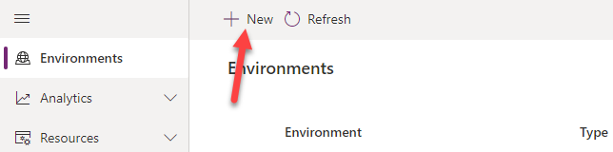

1. Provide an **Environment Name**, select **Trial** for **Type**, select **Region**, select **Yes**, for **Create** a database, and click **Next**.

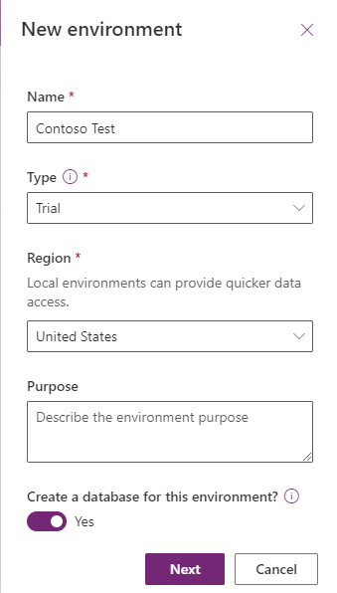

1. Select **Language, URL,** and **Currency**. Choose **Yes** for **Deploy sample apps** **and data** and then click **Save**.

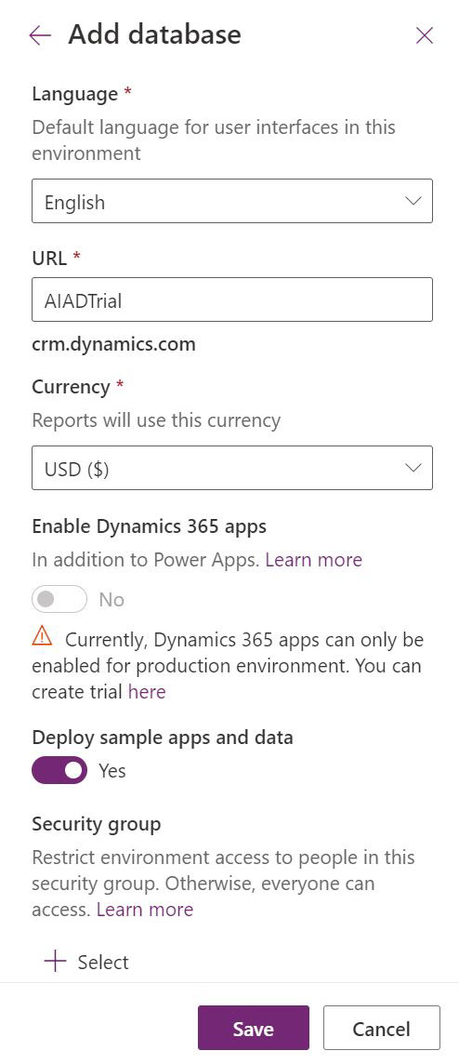

1. Wait for the environment to be created.

## Task 2: Import the solution

In this task, you will import the completed module 4 solution.

1. Navigate to [Power Apps maker portal](https://make.powerapps.com/)
2. Make sure you are in the **Contoso Test** Environment you created.
3. Select **Solutions.**

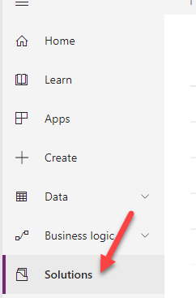

1. Click **Import**.

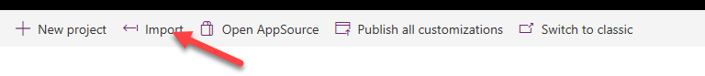

1. Click **Browse**.

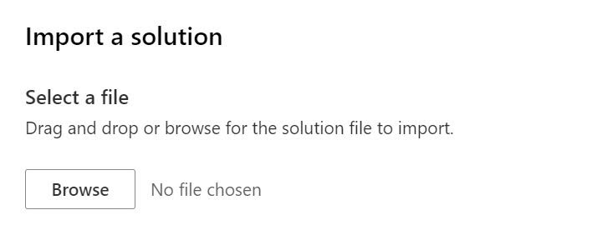

1. Select the **Module 4 Completed Solution** zip file located in Module 4 Completed folder and click **Open**.

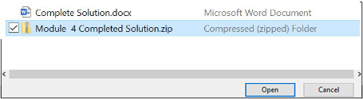

1. Click **Next**.
2. Click **Next** again.
3. Click on the connection dropdown for the **Common Data Service (current environment)** and select **+ New connection**.

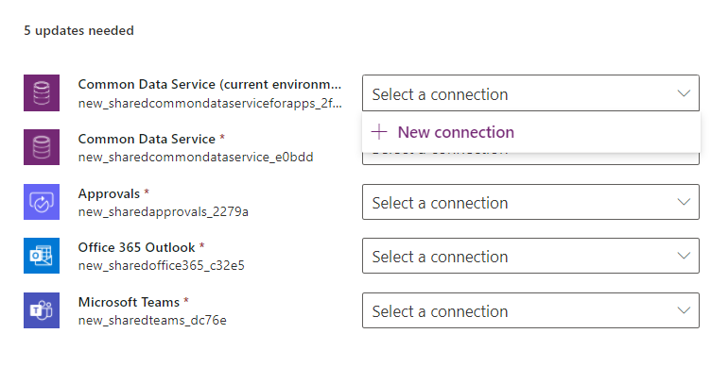

1. Click **Create**.

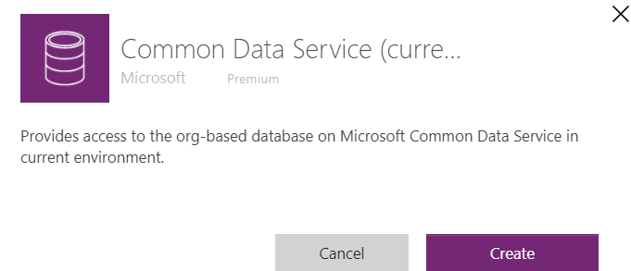

1. Select your credentials.
2. You should now have one connection listed. Close the connections browser tab or window.

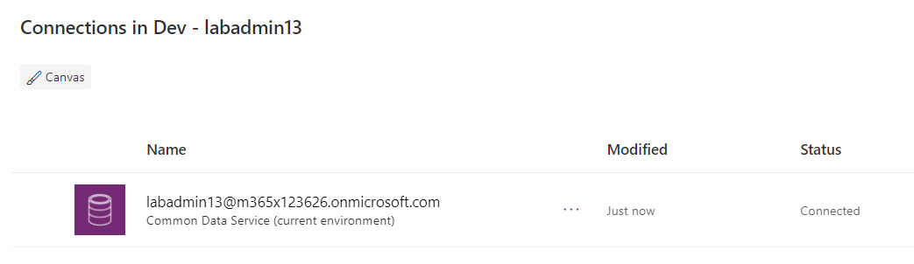

1. Click **Refresh**.

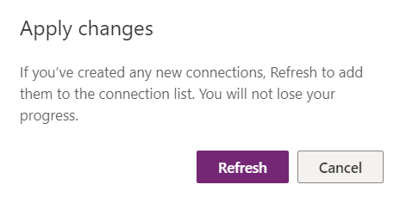

1. The connection you added should get selected. Follow the same steps to add the rest of the connection.
2. Add the connections and click Import.

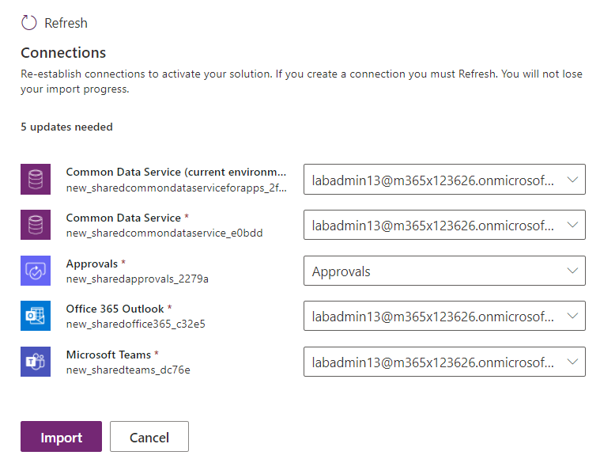

1. Wait for the solution import to complete.
2. Once the import is complete, Click **Publish All Customizations**.

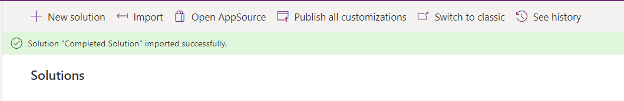

1. Select **Apps**, click on the **…** button of the application you imported and click **Play.**

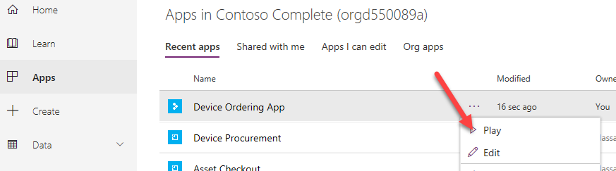

1. Click **Allow**.

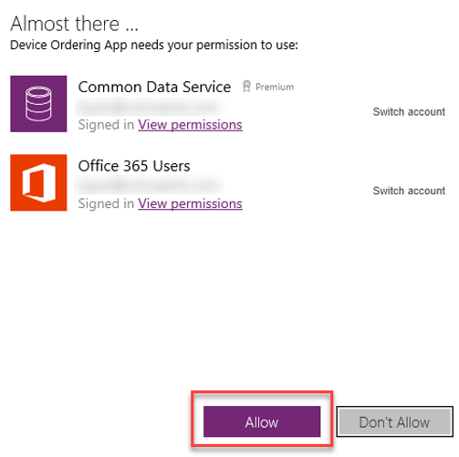

1. Select few devices and click **Compare**.

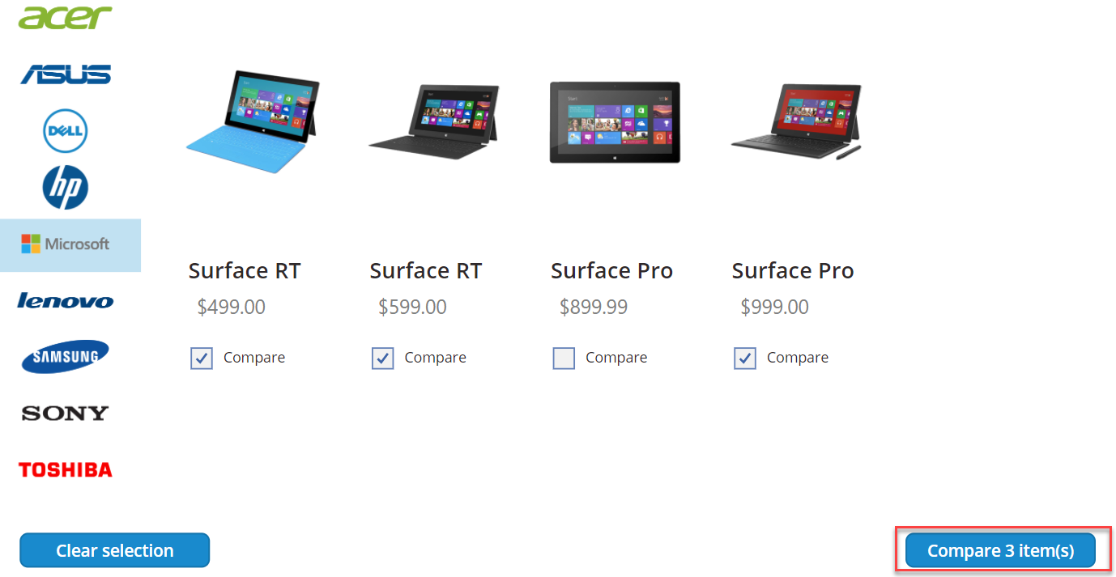

1. Select one of the devices and click **Submit**.

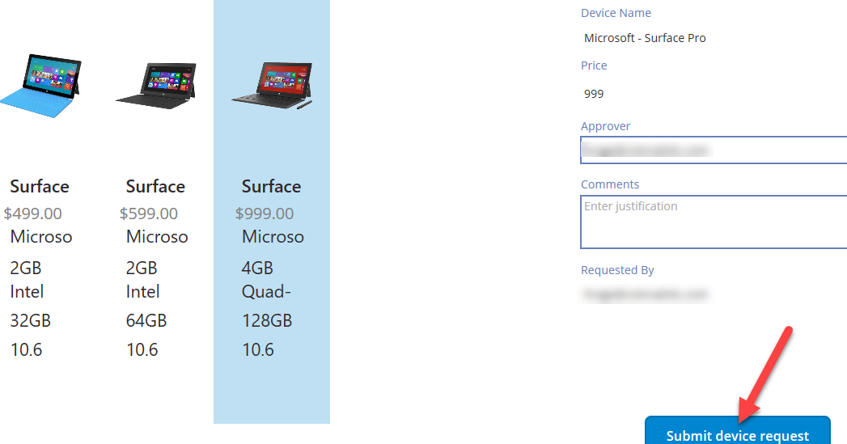

1. Click **OK**.
2. Close the application by simply closing the browser tab.
3. Select **Apps** and start the **Device Procurement** application

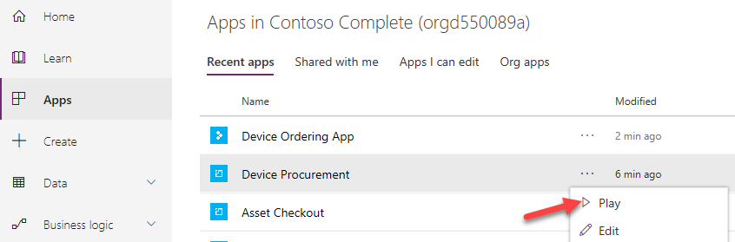

1. Click to open the record you created in the last task.

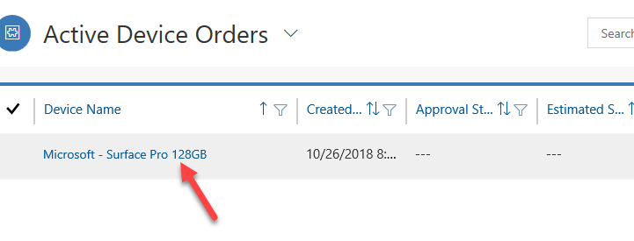

1. The record should open.